1. **Introduction:**

* To generate an attendance sheet for a particular month by inputting the year and the month.
* To generate an attendance sheet for a particular individual for a specific range of dates.

1. **Scope:** Applicable for data stored in Twinkle Database.
2. **The folder where the program resides and how to execute them from the start:**

In Local Server(10.32.26.20)

**Location:** /home/pi/Desktop/Integrate_DB_UDP/Multiuser

**Name of the file:** Data_Display_DB.py

**Dependent file:** Spreadsheet.py, Spreadsheet_headers.py

**How to execute the program:**

* Open the terminal.
* Change the directory by typing:

“cd /home/pi/Desktop/Integrate_DB_UDP/Multiuser”

* To run the program type:

“python3 Data_Display_DB.py.”

**NOTE: The generated Attendance sheets are stored in path:**

“/home/pi/Desktop/Integrate_DB_UDP/Multiuser”

1. **Guide to install the program and configure various parameters:** The program is a self-written script.

**Parameters to be configured:** In the folder Spreadsheet_headers.py, update the parameter “list of holidays” as per the year required.

1. **Detailed Description with diagrams:**

* On running the program, following Main Window pops up:

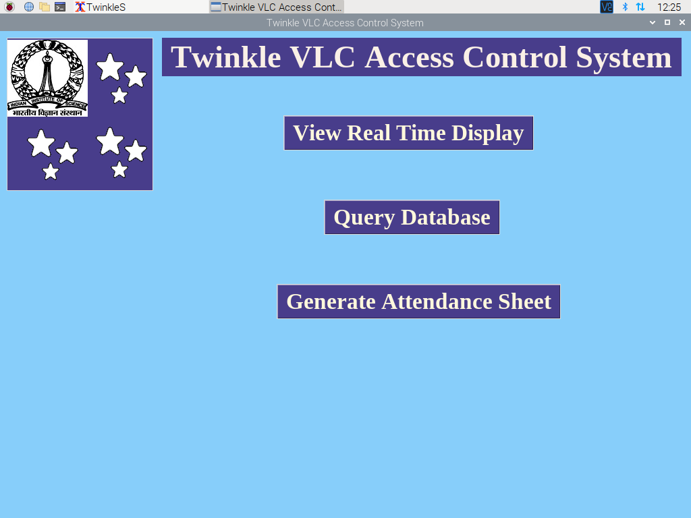

* It has 3 options:
  + View Real Time Display
  + Query Database
  + Generate Attendance Sheet
* **Generate Attendance Sheet:**

For generating Attendance sheet on a monthly basis, click on “Generate Attendance Sheet” in the main window.

On clicking “Generate Attendance Sheet”, following window pops up:

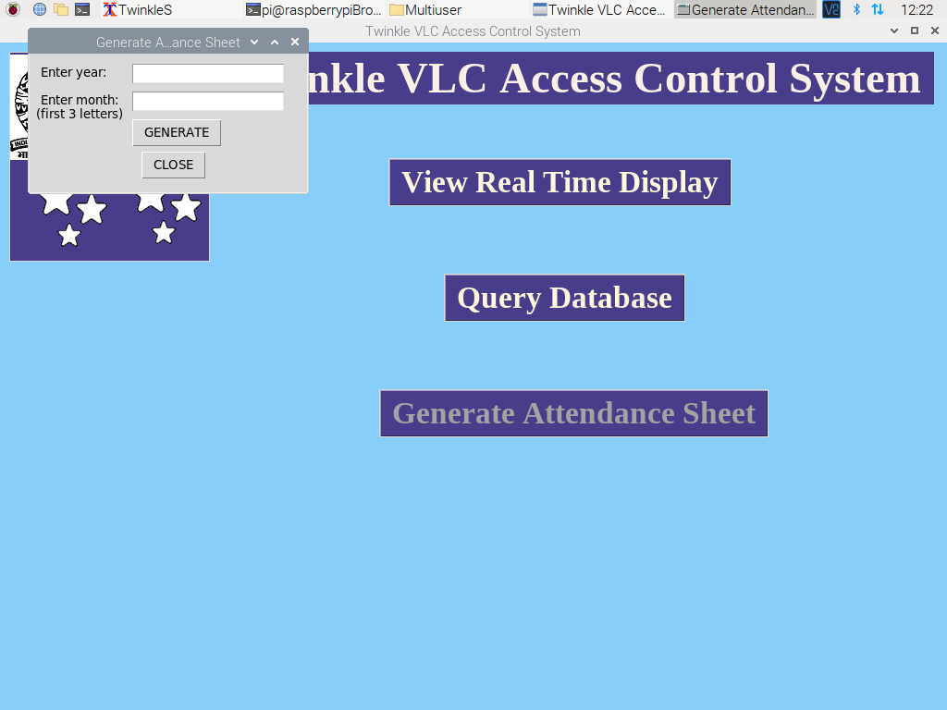

* Enter in the required year and month and click on “GENERATE”:

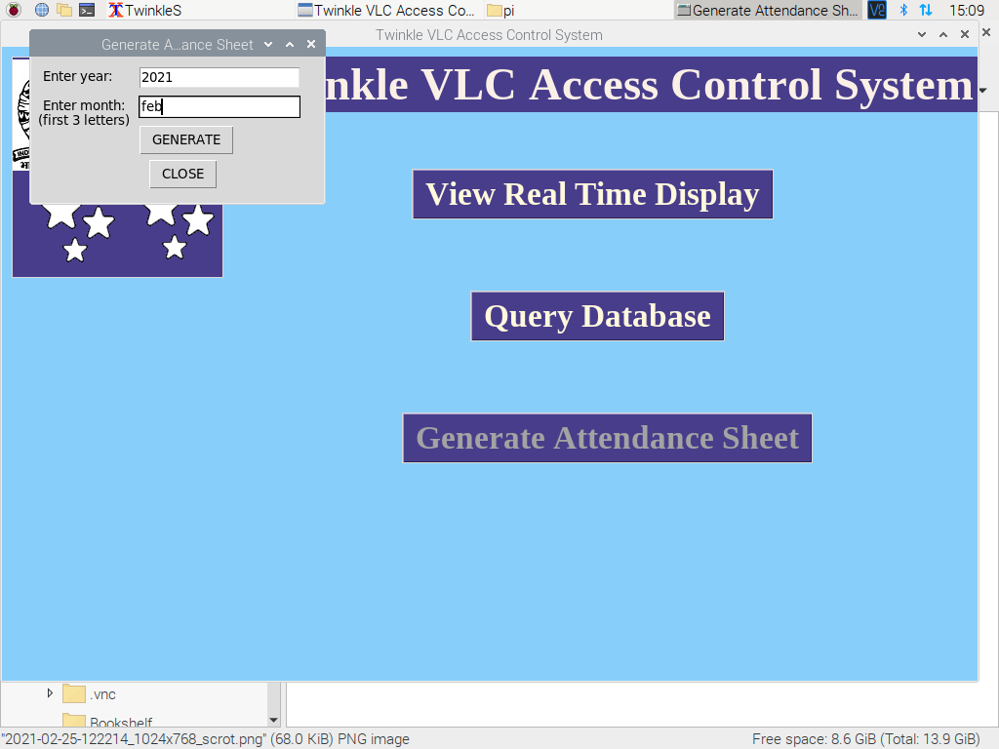

* Sample of the generated Attendance Sheet:

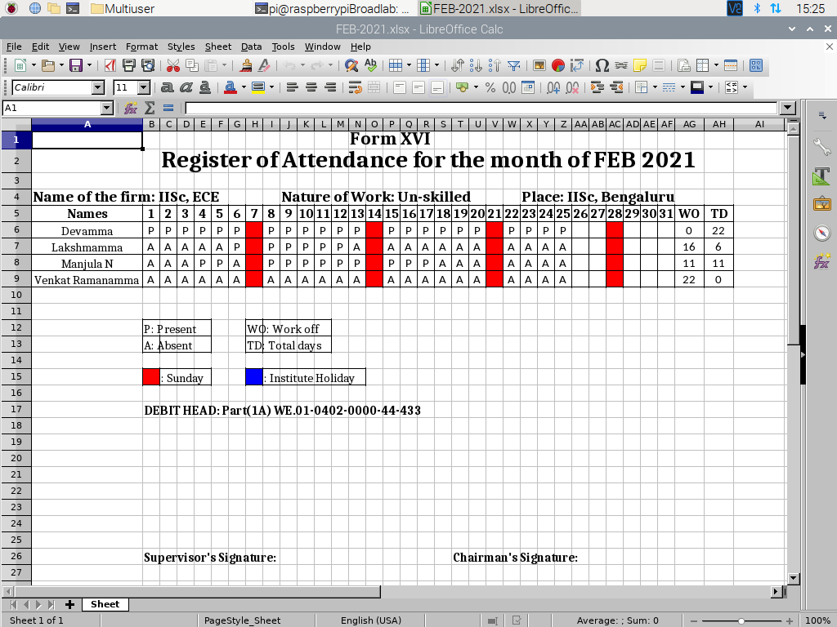

* **Query Datatabase**:

For generating attendance sheet for a particular individual based on a specific range of dates, click on “Query Database” in the main window.

On clicking “Query Database”, following window pops up:

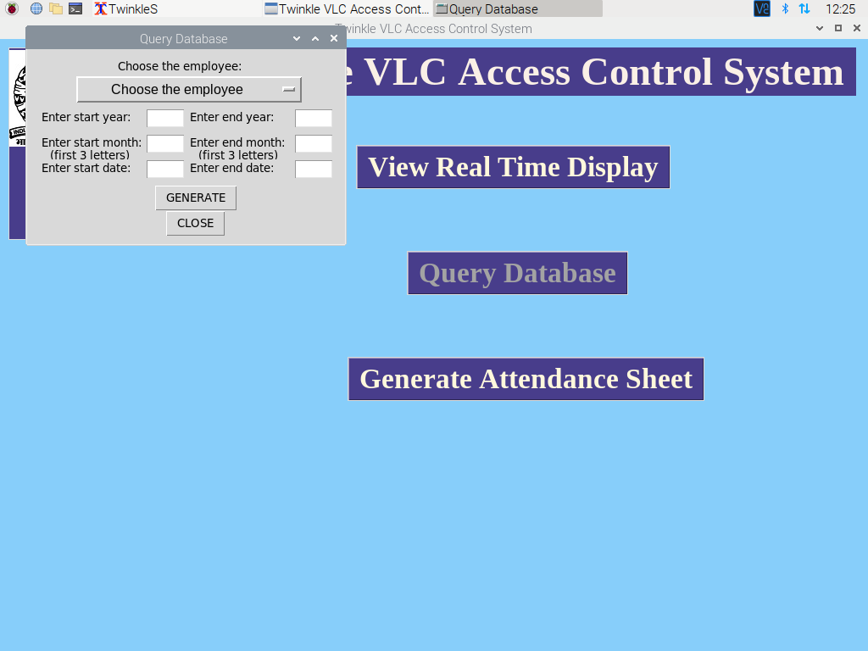

* Select the Employee Name and enter in the range of dates and click on “Generate” Button:

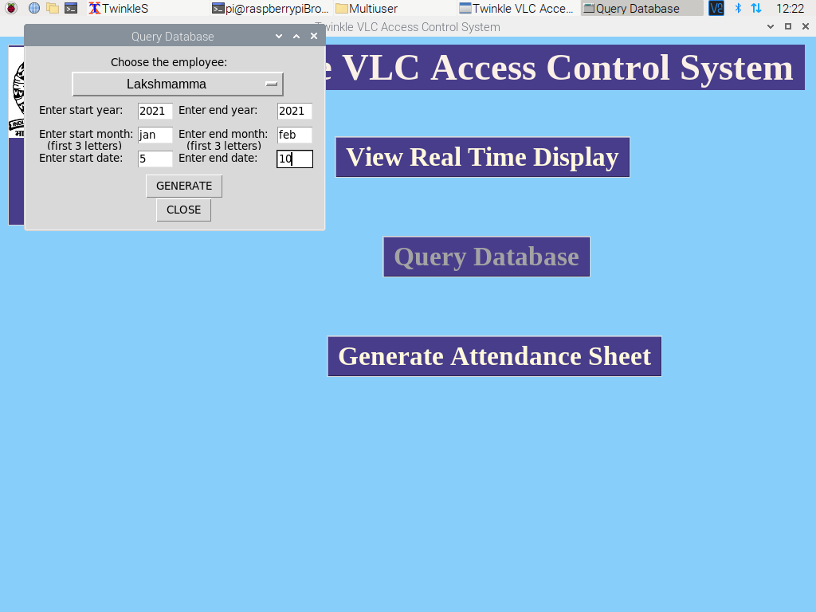

The sample of Generated Attendance sheet:

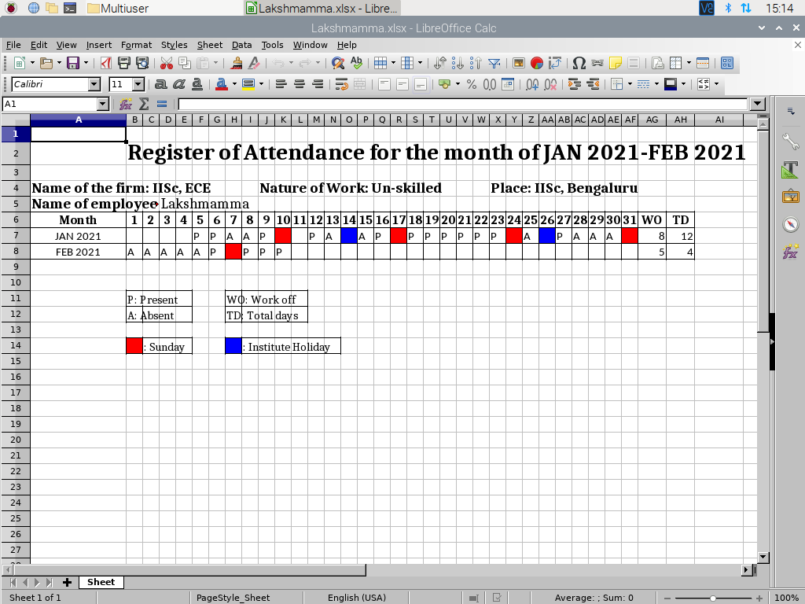

1. **Details about any scripts or 3rd party programs:**

No third-paty scripts is used.

1. **Platforms required for running the programs (PC/RPi ...):**

Raspberry Pi, Linux systems, Windows in softwares like Visual Studio, PyCharm.